information
In the Gospel of Saint Matthew (6:19), Jesus instructs us, "Do not store up for yourselves treasures on earth, where moth and rust destroy, and where thieves break in and steal….” Often in life, we pursue and collect those things that do not last. We must ask, “One hundred years from now, where will our possessions be?” Our greatest blessing is our family. As Orthodox Christians, we are called to be stewards of this great gift. If we are faithful to this calling, perhaps our Lord will say to us as he did to the faithful steward, “Well done good and faithful servant” (Mt 25:23).

NAME

NAME OF SPOUSE (IF MARRIED)

STREET ADDRESS

CITY / STATE / ZIP CODE

HOME PHONE

MOBILE PHONE

EMAIL ADDRESS

EMAIL ADDRESS OF SPOUSE (IF MARRIED)

Dependent Children’s names and birthdates:

May we include your contact information
in the parish directory?

 yes  no If yes, please indicate any information you would like excluded:

May we add you to our parish email list?
 yes  no

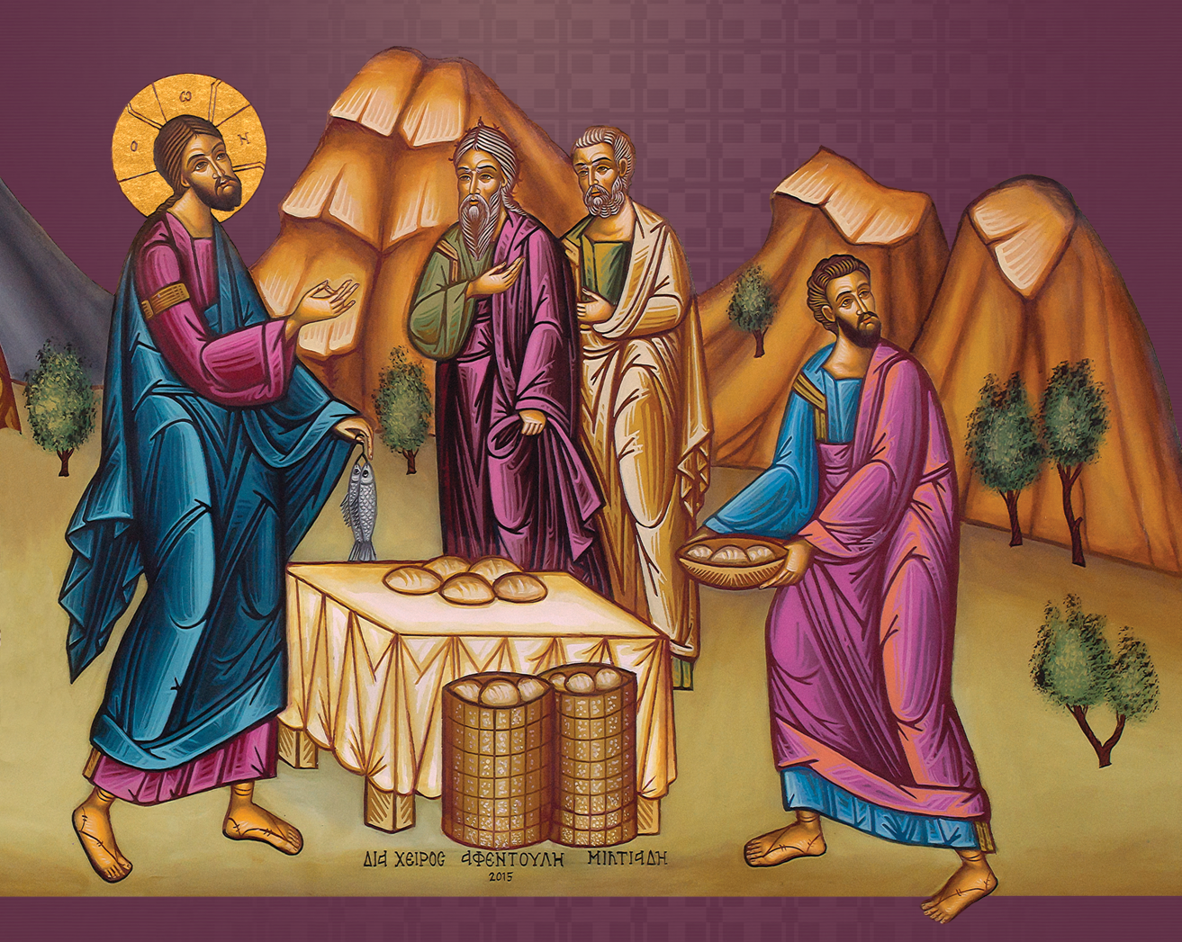

treasure

In gratitude for God’s blessings, I/We commit to Christ and His Church the following amount:

$ each week

planned giving

 Please send me information on making a planned gift to the Church
time & talent
Individual stewards should indicate areas of interest with a check ().

Families should mark “H” for husband, “W” for wife or “C” for children.
LITURGICAL
Sanctuary & Altar Care
Altar boys / Acolytes
Baking Prosfora
Choir
Reader
Greeter/Usher

MINISTRIES & PROGRAMS
Campus Ministry
Welcome Team
New Member Events
Outreach
Stewardship
Sunday Fellowship / Coffee
Visitation – Hospital
Visitation – Shut-ins
Feed the Hungry
Prison Ministry
Grief Bereavement Group
Disaster Relief Projects
Blood Drives
Project Mexico
Int’l Orth Christian Charities
OCMC Mission Center
Seniors Ministry
Couples Ministry
Singles Ministry
Military Ministry

COMMUNICATIONS
Web site & E-mail
Bulletin & Newsletter
Public Relations

EDUCATION
Bible Study
Adult Religious Education
Intro to Orthodoxy
Publications
Speakers
Bookstore
Library

YOUTH
Church School Teacher
Church School Administration
Youth Leader
Vacation Church School
Camp Counselor

BUILDING & GROUNDS
Garden & Landscape
Plumbing
Electrical
Clean-up
Interior Repairs
Exterior Repairs
Roofing
Hall Rentals

ADMINISTRATION
Fiscal Mgt / Review
By-Laws
Development / Fundraising
Office help
Computer / Technical
Data Entry

Any other talents or information on items listed above:

Frequently Asked Questions

How do I become a member of the parish?

Membership in the Orthodox Church begins at baptism (Chrismation for some) and continues throughout our life. We are united with Christ through the sacraments, or mysteries, of the Church and through our faithful offering of our entire selves to Jesus Christ. Our Archdiocese requires each parish to distinguish between voting members and non-voting members. A voting member is over 18 years of age and turns in a signed stewardship commitment card, committing a portion of time, talent and treasure to the Church. The Archdiocese also requires the voting member to remain current through the year on their commitments. Keep in mind that true membership in the Body of Christ involves living according to His word and within His Church.

Why must I commit to give a specific amount?
Please keep in mind that your stewardship of money is kept in the strictest of confidence. However, we do compile the amounts anticipated to better plan our budget.

What if I cannot fulfill my stewardship commitment?
During the course of a year, circumstances change. Your stewardship is valued because it is made out of your love for God and His Church. Please do not be concerned if you are unable to meet your stewardship commitment – we are glad you are a part of this parish.
Christian Stewardship is...

…learning how to be a responsible and concerned caretaker of Christ’s Church; it is learning how to enjoy Church life and be happy in Church work., for in Her dwells the fullness of the Spirit of God.

…our active commitment to use all our time, talent and treasure for the benefit of humankind in grateful acknowledgment of Christ’s redeeming love.

…caring for the needs of others.

…offering one’s self to God as He offered Himself to us.

…what a person does after saying “I believe…”, as proof of that belief.

…devotion and service to God and His Church as persons, as families, as diocese/metropolis, as national Church and as Church universal.

Williams & McKibben in Oriented Leadership

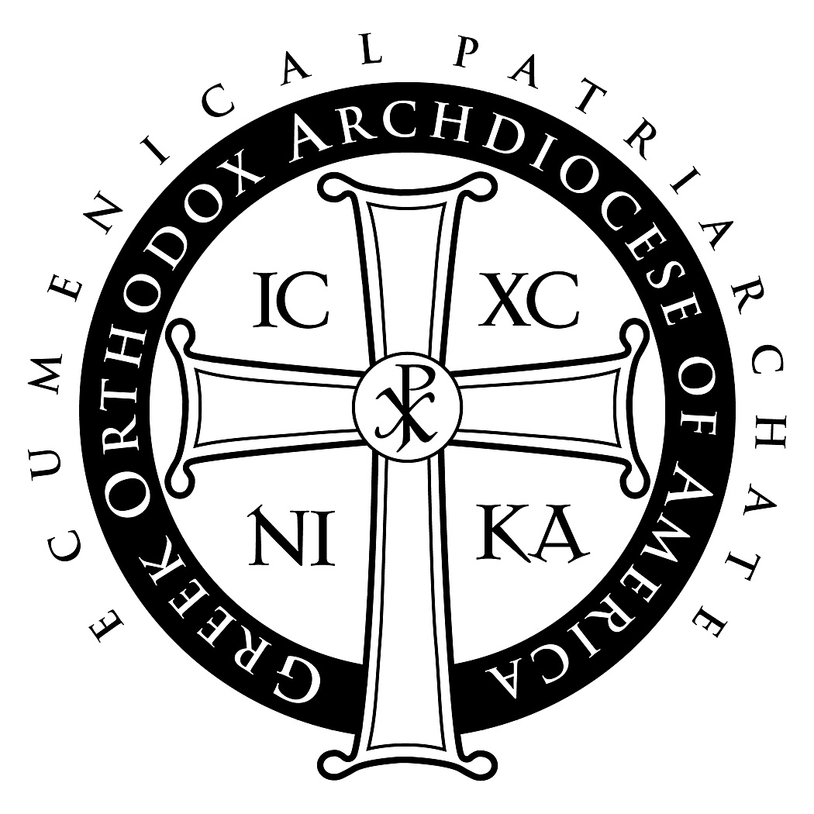

Stewardship Ministries
Department of Stewardship, Outreach & Evangelism
Greek Orthodox Archdiocese of America
307 West 54th Street  New York, NY 10019
646/519-6160  Stewardship@goarch.org



