Table of Contents

Introduction to Stewardship Ministry: Practical Steps 1

As You Organize Your Efforts, Keep in Mind… 4

First Steps in Organizing your Stewardship Program 5

Orthodox Christian Stewardship Program 6

Home Visitation and Small Groups 11

Preparation for Your Parish Stewardship Event 12
What is Stewardship Commitment Sunday?
Stewardship Sunday Invitation Mailing

Stewardship Sunday 14
Stewardship Sunday Program
Collection of Stewardship Cards
Offertory Prayer

Follow-Up Program 15
Ongoing Reminders
Stewardship Offering Statements
Organization of Stewards

End-Of-Year Procedure 16
The Importance of End-of-Year Procedure
Procedure for Steward Categories

Letters 17

Family Information form 23

A steward is one who manages another’s property or resources; the Christian, therefore, is a steward of everything he is and has, including his own body and soul, for according to the mystery of salvation, we possess nothing from ourselves, not even our own life and being; all belongs to God and is given to us by the Father through His Son because of the richness of His love and mercy.
from The Theology of Stewardship in Light of Orthodox Tradition by Fr Paul Wesche (Light and Life Publishing)
Stewardship Ministry: Practical Steps
This booklet and the materials that accompany it are directed to parish leadership throughout the Greek Orthodox Archdiocese of America as part of an ongoing effort to provide practical and inspirational ministry resources. Stewardship Ministries, in coordination with the other national ministries of the Archdiocese, is offering these resources under the unified theme of Abide in Me based on chapter 15 in the Gospel of Saint John.

Effective stewardship ministry is not a single event or project. Rather, it is going out to our people wherever they are in their walk with Christ, listening to their concerns, helping them to realize their importance as branches of the True Vine and encouraging them to offer their gifts in His service. We use various resources to support our efforts, but unless we meet with our people personally, sincerely listen to their ideas and concerns, and share a vision for the future of the parish, our efforts will not each their full potential.

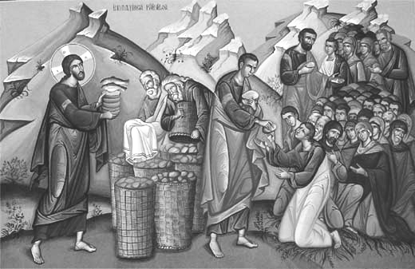
Jesus feeds the Multitudes
If we offer what we are able, God will multiply our offering.

Defining Orthodox Christian Stewardship
In Oriented Leadership their book on Orthodox Christian leadership, Williams and McKibben define stewardship as the call of the faithful to share willingly the gifts that God has bestowed on them, including sharing these gifts for God’s work. Stewardship is devotion and service to God and His Church as persons, as families, as a Parish, as a Metropolis, as a National Church, and as the Church Universal. Stewardship is our active commitment to use ALL our time, talent and treasure for the benefit of humankind in grateful acknowledgement of Christ’s redeeming love.

Stewardship is caring for the needs of others.
Stewardship is offering one’s self to God as He offered Himself to us.
Stewardship is what a person does after saying “I believe…” as proof of that belief.
Williams and McKibben in Oriented Leadership

Clarify Your Parish Mission and Vision
In the words of Fr. William Chiganos of Holy Apostles Church in Westchester, Illinois, “…people don’t give to need; they give to vision…. Church people don’t stretch their giving because of need to meet the budget; they give more because they are able to see a vision of people being reached and God’s purposes being accomplished in the life of the church and its ministry.” Formal strategic planning can help leadership to clarify your Parish mission and vision. Contact the Dept of Stewardship, Outreach & Evangelism for assistance.

Stewardship Works on Many Levels
Parishes with successful Orthodox Christian Stewardship Programs have found that incredible support is unleashed from Stewards who unselfishly and joyfully offer their time, talent and treasures, which in turn enhances the spirituality and ministry of the local parish.

Mail Alone is not Effective Stewardship Ministry
Mailed communication should be considered only a small component of a comprehensive and effective parish stewardship ministry. In a parish where stewardship is soundly established and understood, a mail-only stewardship campaign is likely to only maintain current giving levels, and does not adequately engage members in the life of the parish.

Resources for a Year-Round Effort
The annual packet of resources is directed to parish leadership throughout the Greek Orthodox Archdiocese of America. Every effort is made to support the parish throughout the year in utilizing these resources to personally engage parishioners in the life of the parish. Brochures, posters, sample commitment card, bulletin inserts and more are provided for parish campaigns, with text and graphics included for those parishes designing their own materials based on the Archdiocesan theme. New Greek language materials are complete and are available to parishes as needed. All items are posted to the www.Stewardship.goarch.org site and are on the resources CD included in the resource packet. Please be sure that the Department of Stewardship, Outreach & Evangelism has the email addresses and contact information of your Stewardship Team and priest(s).

National Stewardship Ministries
Stewardship Ministries is led by the National Director of Stewardship, Outreach & Evangelism in cooperation with the Archdiocesan Council Stewardship Committee and includes representatives from each Metropolis and the Archdiocesan District with the goal of sharing best practices from parishes throughout the country and supporting Archdiocesan efforts to provide guidance and practical resources to the parishes.

National Stewardship Training
Transform your Stewardship program with Stewardship Training. Our Training Team offers informative and inspirational Stewardship Seminars for local parishes and groups of parishes seeking to instill a greater understanding of the principles of stewardship and a new paradigm for a strong parish stewardship program. Contact the Department of Stewardship, Outreach & Evangelism to schedule a seminar in your area.

Planned Giving
Include a reminder to members in your stewardship materials to remember the Church their planned giving. Resources for planned giving have been developed by National Stewardship Ministries in cooperation with the Office of Parish Development. These resources are a complete package of information, planning materials and documents to equip the parish to implement a planned giving program.

Parish Management Software
National Stewardship Ministries, in cooperation with the Greek Orthodox Archdiocese Departments of Administration, Finance and Information Technologies has established a Committee on Parish Management Software. The Committee is made up of individuals with expertise and experience in project management, software engineering, accounting, tax law, parish management and more. This committee has evaluated parish management software programs currently available and has chosen Parish Data Systems as the most suitable program for the needs of our parishes. Benefits include favorable pricing due to number of parishes, greater ease of reporting to the Metropolis and Archdiocese through compatible formats, and better support through improved communication between parishes and the software provider. The rollout for implementation in the parishes is currently underway. The committee is seeking funding in order to assist the parishes with implementation and migration of data.

Parish Welcome Folder
To assist and encourage the parishes in reaching out to new members and to inactive members who may be returning to church for a service or sacrament, the department has developed a Welcome Folder which may be personalized by each parish with local information, directories, letters and more.

Stewardship Banners
A full-color, vinyl Stewardship Banner for indoor or outdoor use is available from the Department of Stewardship, Outreach & Evangelism for a nominal cost. This banner incorporates the icon and theme of the current ABIDE IN ME stewardship program. Custom banners are available.

Assistance and Additional Resources
Though we have made every effort to anticipate the needs of the parish stewardship team, the Department of Stewardship, Outreach & Evangelism is available to assist you in your efforts. Contact the Department by email (Stewardship@goarch.org), fax (646-519-6166) or by telephone (646-519-6160).

May God bless your ministry.

Commitment
“It thrives on the belief that the judgment and capabilities of each person are valued and respected. Commitment rises spontaneously when people are treated as persons, and it dies a painful death when people are not.” Williams & McKibben in Oriented Leadership

As you organize your efforts, keep in mind…

Emphasize trust in God, not fundraising techniques:
Encouraging support for ministry requires knowledge, skill, and systems in place. But most important is your trust in our faithful God to use you to help connect God’s people and His resources to His work in the parish and around the world.

Avoid constant special requests for donations, fundraisers, journal ads, etc.:
In order for stewardship to reach its full potential in the parish, the members need to trust that they will not be inundated with additional requests for donations to special causes throughout the year.

Focus on caring for members, not soliciting them:
Find out how you can pray for your members, and do it—over the phone, in person, and in staff meetings. See your efforts as a ministry to your parishioners, and watch the Holy Spirit work through these relationships.

Encourage active stewards to spread the word:
Launch a deliberate effort to specifically ask people for an ongoing commitment to pray, give, and tell others about your parish ministries. Those who commit are with you, so emphasize appreciation and updates with them instead of the usual appeals that everyone else gets.

Look beyond your current needs:
Don’t make the mistake of spending all your time chasing the next gift. Design your stewardship program in such a way that nurtures relationships with your parish members that are strong during and even after their lifetimes. Incorporate Planned Giving into your stewardship materials. Contact the Department of Stewardship, Outreach & Evangelism for information and resources on Planned Giving.

Step up your personal contact strategy:
Ask your parish leaders to help you thank donors—as many and as often as possible. Make stewardship more visible through one-on-one and group meetings.

Let them see what you are doing:
Highlight your successful ongoing ministries and share a vision for future ministries.

Reenergize your member list:
Make a concerted, intentional effort to encourage inactive members to get involved.

Find reasons to communicate more often:
In addition to the normal thank-you note or letter, receipts, and donor updates, find creative ways to stay in touch with your members with parish council and ministry updates, new plans, other ministry news, etc. Use good-quality photos.

Parishes must also be good stewards:
Take a hard look at your expenses and see if any could be cut or delayed. Share this budget tightening with members so that they know that parish leaders are also being good stewards of the funds entrusted to them.
First Steps in Parish Stewardship Ministry

Preparation

Under the spiritual guidance of your parish priest…
- Meditate on the National Ministries theme;
- Form your Parish Stewardship Team early;
- Build your team of people blessed with a variety of gifts, training and experience;
- Keep the Parish Council informed and active in promoting Stewardship;
- Coordinate communications focusing on stewardship throughout the year;
- Train and encourage team members in outreach and welcoming ministry; and
- Focus on Stewardship of Time, Talent, and Treasure – know the gifts & talents of your people.

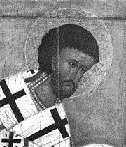
“The most basic task of the Church leader is to discern the spiritual gifts of all those under his authority, and to encourage those gifts to be used to the full for the benefit of all. Only a person who can discern the gifts of others and can humbly rejoice at the flowering of those gifts is fit to lead the Church.” - Saint John Chrysostom

Remember that…
- Active parishioners have a sense of connection to the True Vine;
- Parishioners need to know that their concerns are being heard;
- Parish leaders are called to provide opportunities for the spiritual growth of parishioners; and
- Active and dedicated parishioners will want to support the church financially.


Just as the vine bears fruit only through its branches, so Jesus has chosen to work in the world through us. We are the members of His body – the branches through which the Vine must bear fruit. We bear fruit when we serve and support God and His Church.

Organizing and Planning
- An effective Parish Stewardship Chair understands and is passionate about ministry;
- The Priest is the spiritual advisor and primary spokesperson/advocate for stewardship through sermons, bulletins, newsletters and visitations.
- A parish council member should act as liaison to the Stewardship Team.
- Team members must lead by example with 100% participation in stewardship.
- The team plans the stewardship year, the distribution of stewardship materials, events, visitations, focus groups, seminars and the general follow-up effort.
- Regular communication among team members by email, conference call and meetings are more frequent in preparation for the stewardship event.
- Personal contact through which parishioners’ concerns and suggestions are heard and noted by the Stewardship Team is critical to the success of the program.
- In-home visitation by members of the team has been shown to be the most effective way of increasing members’ connection to the parish and awareness of current and proposed ministries.
- Small groups, focus groups and town hall meetings may be used to supplement individual home visitations or they may be a substitute if visits are not feasible.
Orthodox Christian Stewardship Program
Though much of this section deals with the mechanics of implementing a stewardship program and the administration of the financial aspect of stewardship, we should not forget that Stewardship is a holistic concept involving the entire person. It is for this reason that the stewardship commitment card asks for the commitment of time, talent and treasure.

Stewardship and the Steward
Orthodox Christian Stewardship is a way of life, which acknowledges accountability, reverence, and responsibility before God. A primary goal of Stewardship is to promote spiritual growth and strengthen faith. Becoming a Steward begins when we believe in God, to whom we give our love, loyalty and trust and act on those beliefs. As Stewards, we affirm that every aspect of our lives comes as a gift from Him. Stewardship calls on the faithful to cheerfully offer back to God a portion of the gifts with which they have been blessed.

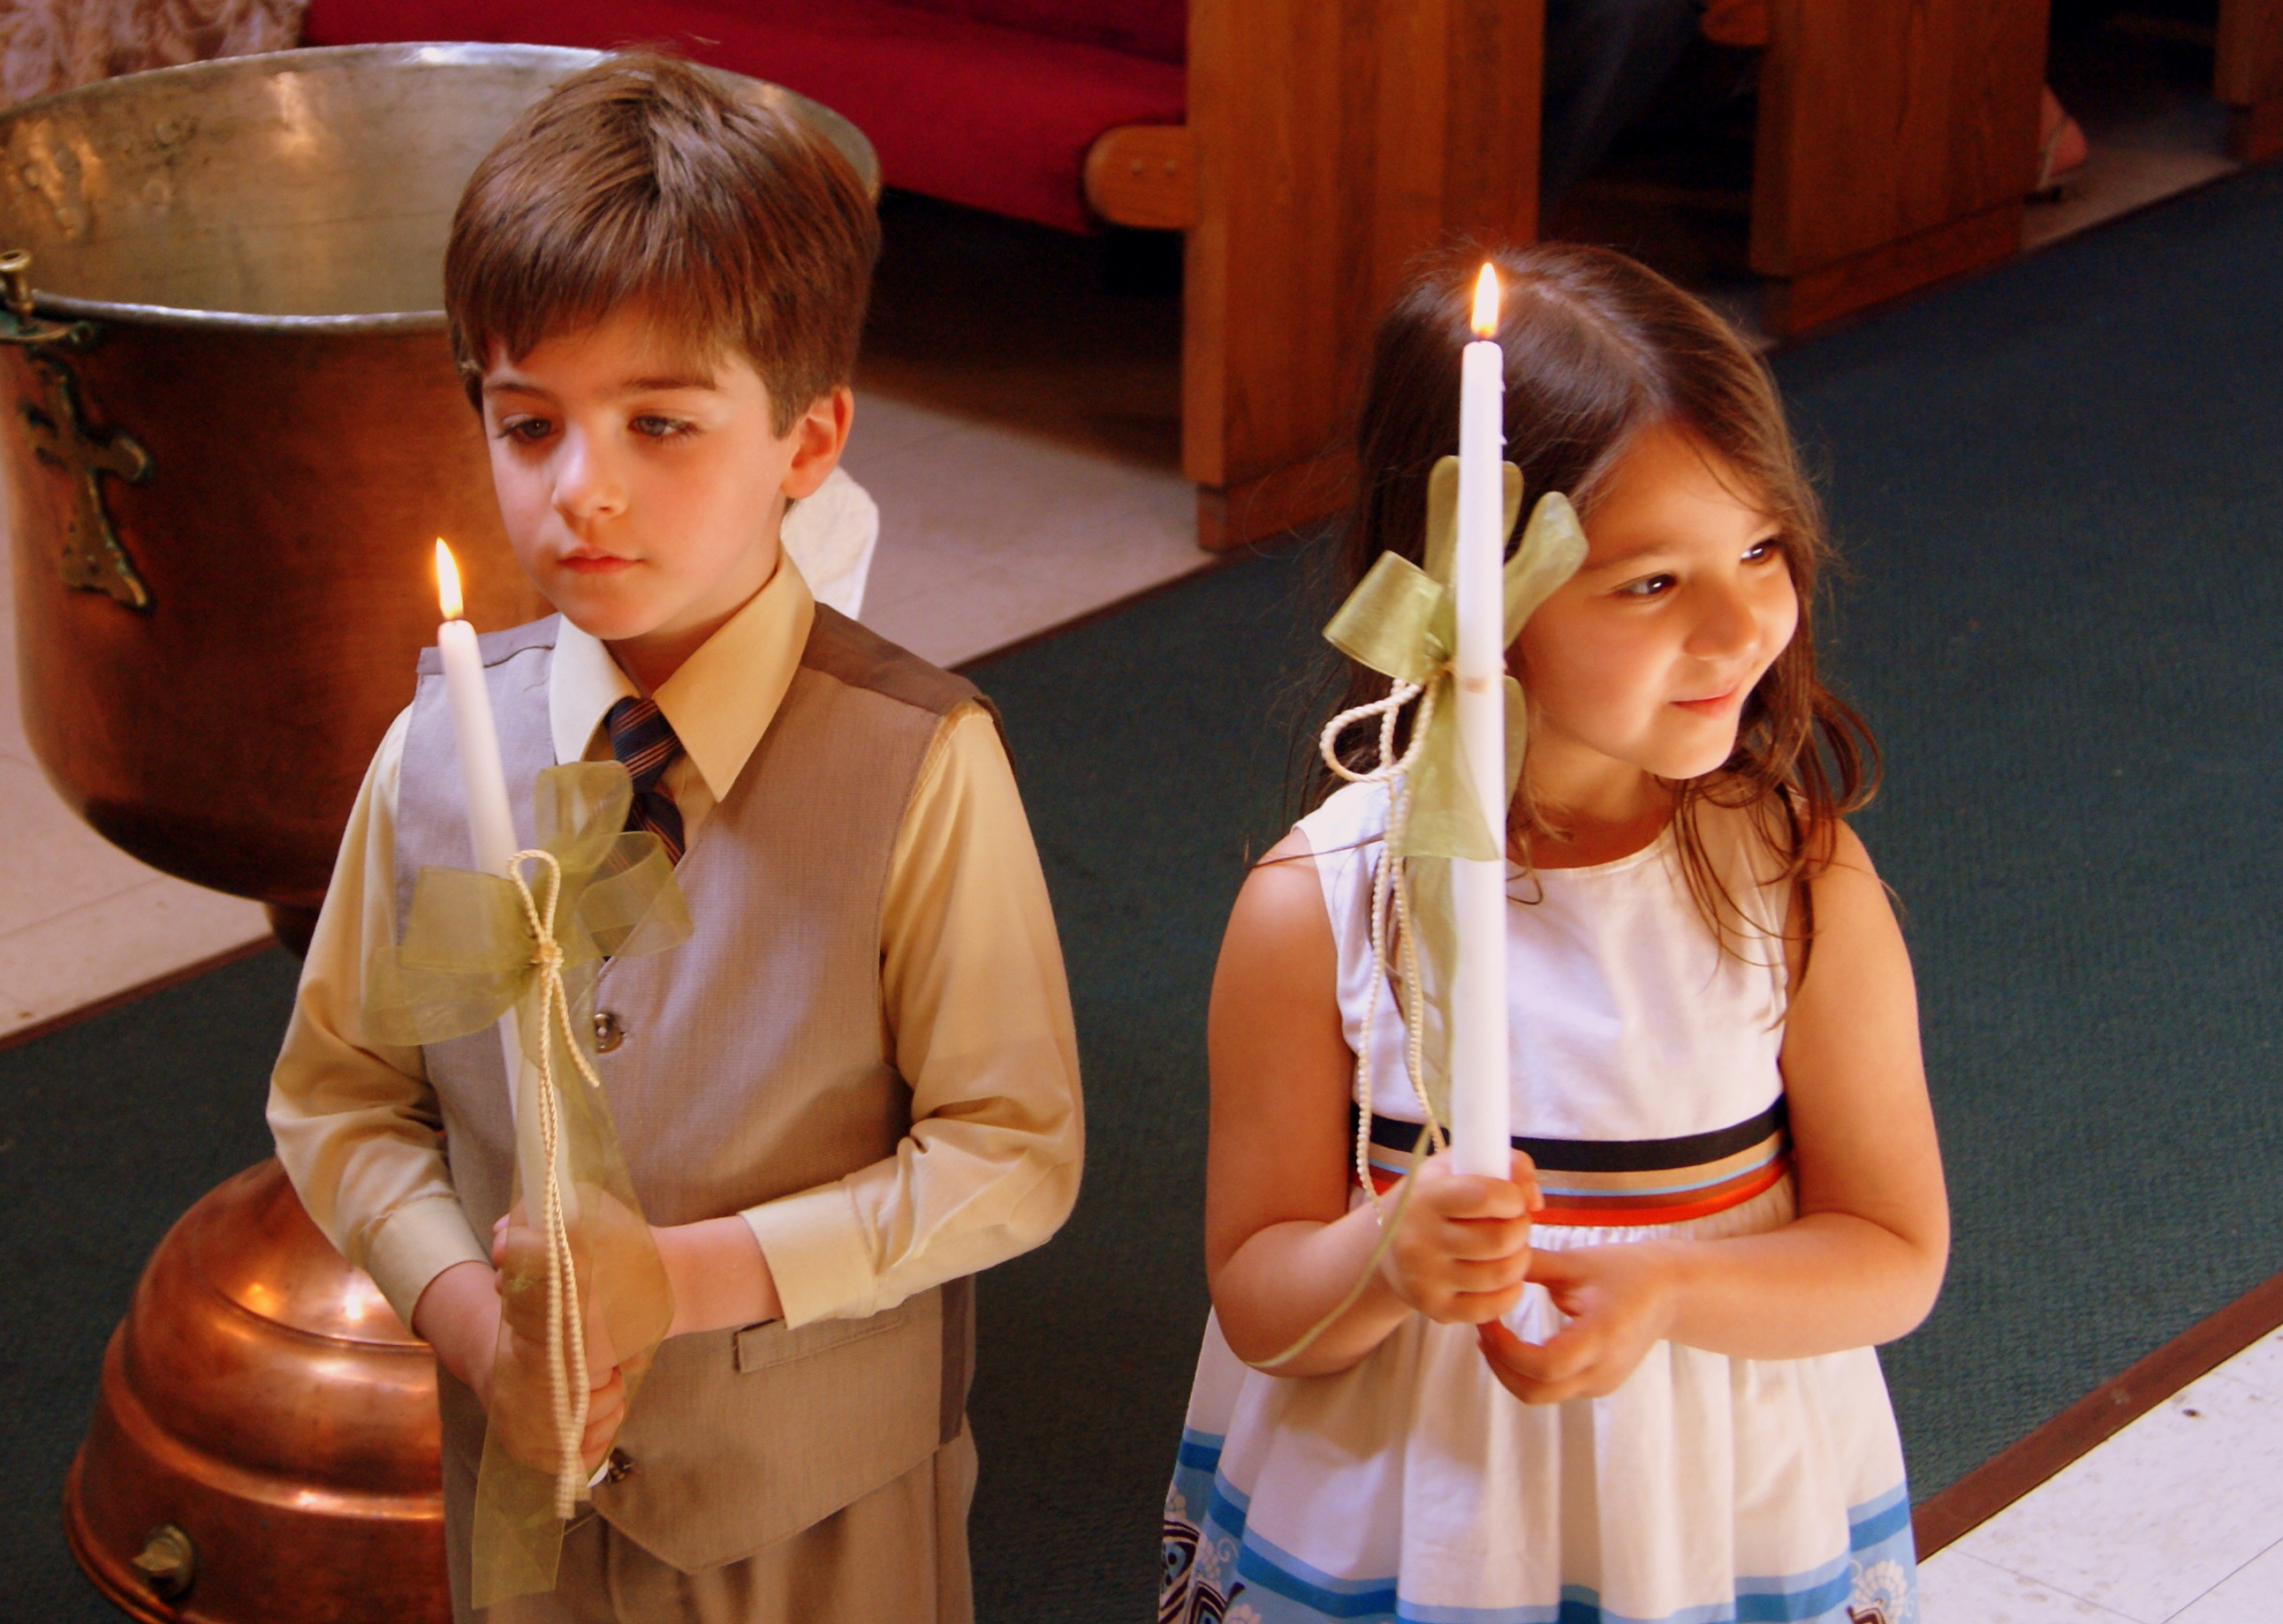
An Orthodox Christian Steward is an active participant in the life of the Church. The parish encourages all who accept the Orthodox Faith to become practicing Stewards. Each year the Steward is expected to carefully review his or her personal circumstances and make a commitment of time, talent, and treasure to support the Parish and her Ministries, which in turn support the National Ministries of our Archdiocese, Metropolises, and institutions.

Stewardship and Budget
A successful Orthodox Christian Stewardship Program should provide for the entire Parish Ministries and Operating Budget as well as the growth of those ministries. The parish, in time, will not find it necessary to depend on festivals and other events to meet its financial responsibilities. When a parish first enters into the Orthodox Christian Stewardship Program, proceeds from such events supplement Stewardship revenue shortfalls in meeting the parish budget. After a few years of concentrated effort and a positive attitude, Stewardship revenues should completely support and provide total coverage and even allow for growth of the budget. Once this has been achieved, festivals and other events may be seen as community events and outreach opportunities, with proceeds going to the capital improvements and/or the philanthropic work of the Church.

An Inspirational Budget
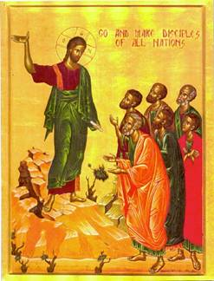
A budget is an expression of the vision of the parish – its priorities, concerns and plans for the future. Members who see a church doing more than “paying the bills” will be inspired by the vision of a church that seeks to serve its parishioners, neighbors and people in need throughout the world. The parish might consider line-items for Charitable Programs, Missions, Outreach, Youth Worker training, Adult Education, Educational Outreach Materials and more. Though some may balk at this extra burden on the budget, others will be inspired by the vision of a parish interested in improving and adding to its ministries.
Stewardship and the Parish Priest
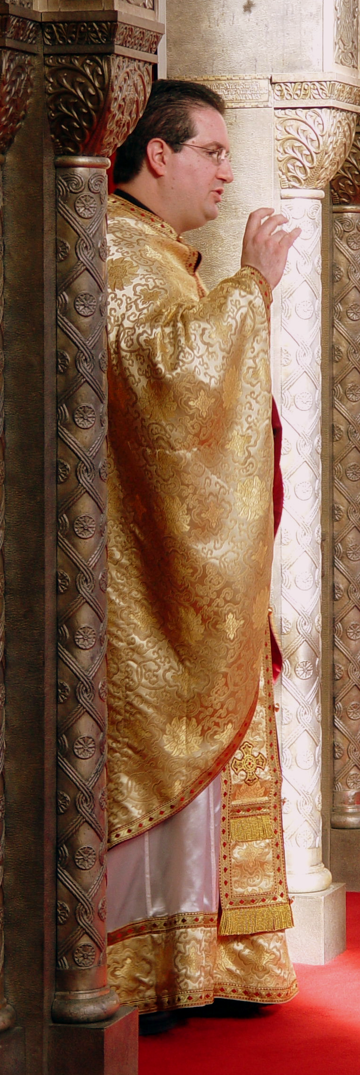
The foremost purpose of the Steward’s offering of time, talents, and treasures is to support, maintain and grow the spirituality of the parish. This requires that the Stewardship Committee work closely with the Parish Priest.

The success of the Orthodox Christian Stewardship Program may be directly attributed to the spiritual leadership of the Priest working together with the dedicated Stewardship Committee and Parish Council members. It is suggested that the message of Stewardship be woven into the Priest’s sermons, pulpit announcements, and the parish print and electronic media. Statistics have shown that if the Priest does not preach convincingly and project regularly the concept of Stewardship of time, talent and treasure, the program will not be successful. The Priest has the spiritual responsibility to teach Stewardship, which is the Christian understanding of all that we possess – time, talent and treasure.

Engaging our Members: Personal Visitation and Small Group Ministry
The focus of our efforts is engaging the individual member in the life of the parish. In-home visitations have proven to be an effective approach to stewardship education and participation. It is suggested that a parish plan be developed for visiting every parishioner in their home over a feasible period of time. The visit could include prayer, a conversation outlining the vision of the parish and conveying the understanding that every person is an important part of the body of Christ. A good conversation starter is the Come and See DVD (7 minutes in length) distributed with the 2011 Stewardship Resources. This may be viewed on the stewardship web site at www.stewardship.goarch.org and is available in DVD format from the Department of Stewardship, Outreach & Evangelism. During visits with parishioners, it is imperative that team members take time to listen to the people being visited, take note of what is important to them and acknowledge their concerns.

Follow-up would include a hand-written note and/or telephone call. Parish ministry information or resources could be sent that pertain to questions or concerns raised in the conversation, as well as actions being taken by the parish to remedy their concerns. The visitation team should also confidentially inform the priest of any need for special ministry to the specific needs of an individual or family.

Small group stewardship ministry is an alternative to individual home visits and is more effective than simply mailing stewardship materials. It is suggested that groups of 10 to 20 individuals be formally invited to meet in a home, the church library or fellowship room. The meeting would include prayer, a conversation outlining the vision of the parish. Team members should take time to listen to the people, discussing what is important to them and acknowledging their concerns. Follow-up would be the same as for in-home visitations.

It is Far More Important to be Interested than Interesting
In all of our meetings and conversations with members, it is far more important to be interested than interesting. Listening is more important than talking. The focus should be on the individual – their needs, concerns, questions, ideas and suggestions. Ideas and suggestions must be heard and referred to the appropriate individual or organization with a thoughtful response indicating that they have been heard and that they will be: 1. implemented, 2. implemented at a later date, or 3 not implemented with specific reasons. Many people disengage from active participation in church life because they feel that the parish leadership is a closed group that does not respond to their ideas.

No Minimum or Maximum Commitment
All parishioners freely declare their annual commitment by submitting a Stewardship Commitment Card. The fundamental premise of Stewardship is free-will giving, with each individual giving as he or she is able in order to advance the ministries of the Church. In accordance with the principle of free-will giving, there should be no minimum or maximum Stewardship commitment.

Need for Communication
The message of Stewardship should be kept at the forefront of the congregation through regular communication throughout the year, especially at the inauguration of the Stewardship Program. Sermons, reflections, announcements, bulletins, newsletters, the Bulletin Builder Program (www.bulletin.goarch.org), the parish e-mail list (a free service of the Archdiocese) posters and brochures are important components of a comprehensive, year-round stewardship program. Experience has shown that stewardship offering envelopes and the mailing of monthly/quarterly Stewardship statements to all Stewards increases the timely fulfillment of Stewardship commitments. Follow-up telephone calls are also a very effective means of connecting with our members.

Church Management Software
Many parishes utilize church management software programs to assist in compiling and managing Stewardship information. Information provided by church management programs assists parish ministries by providing a dynamic record of member families and their parish involvements. This software is invaluable to a strong Stewardship Program, providing information needed for ministry to specific segments of the parish. Please see the section on Page 3 of this booklet for information on the Parish Management Software

Parish Print and Electronic Media
As mentioned above, the message of Stewardship can be reinforced through brochures, posters, the parish newsletter, the Sunday bulletin, E-Bulletins (www.bulletin.goarch.org), the parish web site, the parish e-mail list (a free service of the Archdiocese) and more. Stewards should be encouraged to offer their time & talent as well as treasure to the ministries of the Church. The stewardship team may also choose to produce a parish Stewardship Newsletter, depicting active parish life and offering inspirational messages and updates on stewardship commitments year-to-date. A Subcommittee on Internet & Web Strategies was recently formed to develop ideas and resources for parish ministry.

Personal Follow-up Letters
Personal follow-up letters will support the stewardship effort.
Consider sending a personalized thank you letter for:
- each stewardship commitment;
- offerings at year’s end; and
- providing their time and talent after a parish function or activity.
New Stewards
Orthodox Christians become Stewards of your Parish as a part of their spiritual growth. Other contributing factors are good Christian Education, a sense of belonging & participation, effective Youth Ministries, and the desire to take part in the sacraments and rites of the Church. When individuals indicate an interest in becoming Stewards of your parish, the church staff should send the prospective Stewards a Welcome Packet which would include Enrollment Information which they are to complete and return. The Priest and the Stewardship Committee Chairman may choose to arrange for an introductory meeting with prospective and new Stewards. This will provide an opportunity to familiarize them with the Parish Ministries and the Stewardship Program. Welcome Folders are available from the Department of Stewardship, Outreach and Evangelism.

New Steward Enrollment Information Mailing
The Stewardship Enrollment Information Packet might include:
- An Invitation Letter, personally inviting the individuals to become Stewards, with a short description of their responsibilities;
- A Family Information Card;
- A Stewardship Commitment Card and return envelope;
- Additional parish information – current bulletin, newsletter, etc.;
- A relevant brochure from Stewardship, Outreach & Evangelism; and
- A planned giving brochure to encourage larger gifts and bequests.

New Steward Enrollment Procedure
The Family Information Card and Stewardship Commitment Card should be completed and returned to the Church Office and be entered into the parish database. The new Stewards will then receive all parish communications and offering envelopes and be entered as subscribers to the Orthodox Observer.

Some parishes offer online enrollment and pledging through the parish website.

Collection / Methods of Payment
- Offering Basket: During the Sunday Divine Liturgy, weekly stewardship envelopes may be placed in the offering tray passed during Divine Liturgy or placed in an appropriate location in the narthex.
- By Mail: Regular weekly or monthly stewardship contributions may be mailed to the church office. Stewards should use offering envelopes or clearly indicate their membership number so that the purpose of their contribution is clear to those who process the payment.
- Online Bill Payment: More and more people handle their financial commitments electronically. This is a very suitable method for offering our “first fruits” to the Lord rather than offering only that which remains. Stewards may very easily set up automatic periodic payments from their bank to the church in fulfillment of their stewardship obligation. A payment module may also be added to the parish web site.
- Parish Pay / PayPal: There are a number of companies facilitating payment by debit or credit card. Many parishes have set up links on their parish web site permitting individuals to submit their financial support through an online credit or debit payment.

Weekly Offering Envelopes
A weekly envelope system works well as a collection vehicle for some parishioners, a reminder for others, and a way to send offerings when attending Church is not possible. A significant percentage of the offerings may be received through the mail.

Consider offering envelopes for Sunday School students and encourage teachers to instill in their students the Orthodox Christian principles of Stewardship.

Make Your Parish Stewardship Program a Year-Round Effort
Through creative understanding of the specific make-up of your parish, the Parish Stewardship Team should tailor the Parish Stewardship Program to have the greatest impact on as many parishioners as possible. Stewardship goes hand-in-hand with outreach as we welcome new members into our parish each week. It is also critical that we strengthen the connection of existing members to the parish. As people begin to feel more connected to the parish, they also want to offer their time, talent and treasure in support of her ministries.

Though many parishes designate one month as their stewardship month, the parish Stewardship Committee, in consultation with the parish priest should plan a year-round calendar of stewardship ministry. Awareness and understanding of the importance of stewardship can be increased throughout the year in the Sunday sermon, speakers of all ages sharing the importance of the Church in their lives, Sunday bulletins, newsletters, Stewardship literature, Stewardship PowerPoint presentations, slide shows or videos of parish life, community luncheons, and much more.

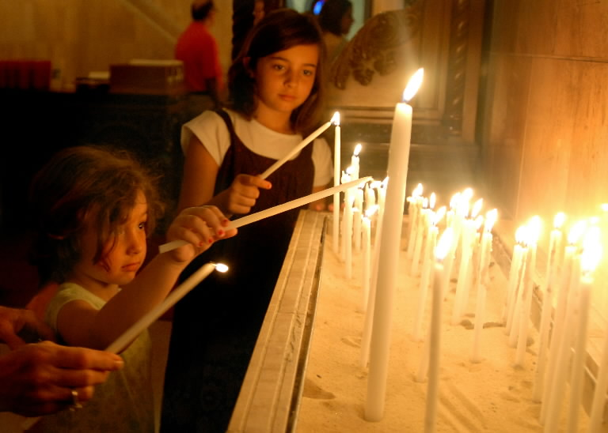
Home Visitations & Small Groups
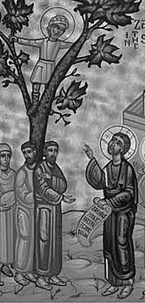
When Jesus visited Zacchaeus in his home, he was converted by Christ’s visit and acceptance of him. We are called to emulate the ministry of Jesus, visiting our parishioners, listening to them and seeking to re-engage them in the life of the Church. Personal, in-home visits are absolutely the most effective method of stewardship ministry. It’s PERSONAL!

Establish a Stewardship Ambassador Committee made up of dedicated stewards. It is critical that a large enough number of ambassadors is recruited so that no one has to visit more than 10 homes.

Conduct training programs for the ambassadors regarding vision of the parish, the Orthodox Christian understanding of stewardship, the importance of listening attentively, validating concerns, reflective listening and more. Practice answering objections / concerns / complaints in a positive manner. Encourage ambassadors to make a mental note of potential areas of involvement for the person(s) being visited, as well as special needs for which various ministries of the parish might be of assistance. Also, any pastoral issues should be referred confidentially to the priest.

Ambassadors should be given a list of stewards for visitation that is made up of people with similar interests, activities, circumstances and involvements. Geography should also be taken into consideration.

Optimally, all stewards could be visited over the span of a year. If there are not enough volunteers to do so, the process could be spread over 2 or 3 years.

Small Group Gatherings or Focus Groups are more effective than mail-only, but not as effective as individual visitations. To do this, a formal invitation is sent to participate in a group meeting at a home or fellowship area of the church. This program should include testimonials and allow for each individual to share their experiences and ideas for the church. These meetings must be moderated carefully to keep the tone positive and constructive.

Moderators should also be making mental notes as in the home visit for ministry needs and potential parish involvements of the participants.

The goal of personal contact is to engage the individual in the life of the parish. It is more important for the ambassador to be interested rather than interesting. People want to be heard and for their opinions and ideas to be considered. This will require effective and personal follow-up.

Contact the Department of Stewardship, Outreach & Evangelism to arrange for training in the Ambassadors Program.
Preparation for the Annual Stewardship Event

The Stewardship Commitment Event should be seen as the inauguration of the year-round calendar of Stewardship Ministry.

Prior to the event, prospective Stewards receive a Stewardship Mailing explaining the program and its importance to their spiritual life and the growth of Parish Ministries. The mailing is an invitation to become a Steward (a Commitment Card is enclosed in the mailing), as well as to participate in the Stewardship Event. These activities may include some or all of the following:
- Stewardship sermon or series of sermons given by the Priest;
- Testimonial by Stewards of various ages and parish involvements;
- Special collection of commitment cards;
- Offertory Prayer;
- Reception, luncheon, or other special fellowship activities; and
- A multi-week Stewardship campaign culminating in Stewardship Sunday.

Choosing the Dates
A Sunday or a series of Sundays in November prior to Thanksgiving Day or dates more suitable for your parish calendar should be designated for the Stewardship Event. It is best to inaugurate the Stewardship Program at the same time each year. The dates should be chosen early to allow for proper preparation. Scheduling conflicts will arise, so have your date approved by your parish priest and parish administrator. Be aware that the Sunday prior to Thanksgiving is traditionally IOCC Sunday (designated by SCOBA).

Stewardship Event Invitation Mailing
The Stewardship Committee, with oversight from the parish Priest, prepares the Stewardship Event Invitation Mailing. The mailing deadline should be at least 10 days before the first Sunday of the Stewardship Event or 21 days before Stewardship Commitment Sunday. The Invitation Mailing should contain the following five items:
- Invitation Letter from the Priest;
- Stewardship Commitment Card;
- Tri-Fold brochures;
- A #9 return envelope addressed to the Stewardship Program at your parish; and
- A #10 envelope in which to mail the above items, printed with the Steward’s name and address.

The Invitation Letter prepared by the parish Priest is addressed to the Stewards of the parish. The letter informs the stewards of the designated Sundays and requests that Stewards bring their Commitment Cards on Stewardship Sunday or mail them to the church office. The letter should personalized by computer merge with the Steward’s name, address and greeting, producing a personalized letter for each Steward.
An ideal approach would have a letter that is focused on the individual member’s demographics and level of parish involvement. The vision of the parish should be outlined and include the parish mission statement (if one has been formulated) or aspects of the mission statement of the Archdiocese:

The mission of the Archdiocese is to proclaim the Gospel of Christ, to teach and spread the Orthodox Christian faith, to energize, cultivate and guide the life of the Church in the United States of America according to the Orthodox Christian faith and Sacred Tradition.

The Archdiocese sanctifies the faithful through the Divine Worship, especially the Holy Eucharist and other Sacraments, building the spiritual and ethical life of the faithful in accordance with the Holy Scriptures, Sacred Tradition, the doctrines and canons of the Ecumenical and local Synods, the canons of the Holy Apostles and Fathers of the Church and of all other Synods recognized by the Orthodox Church, as interpreted by the Great Church of Christ in Constantinople.

The Archdiocese serves as a beacon, carrier and witness of the message of Christ to all persons who live in the United States of America, through Divine Worship, preaching, teaching and living the Orthodox Christian faith. As to its intra-Orthodox, intra-Christian and inter-religious activities, the Archdiocese follows the positions and guidelines established by the Ecumenical Patriarchate.

The letter should illustrate to the parishioner three major accomplishments in ministry of the past year and three ministry goals for the coming year. People are more likely to respond positively to vision that produces results. It is suggested that those ministry goals and accomplishments include youth ministry and ministry to seniors, as well as some form of outreach or service to the community.

The Stewardship Commitment Card is preprinted with the Steward’s name, address, and a place for the amount to be offered. The name and address should be merged onto the card or labels may be prepared and placed in the designated area. A sample Commitment Card is provided in the 2012 resource packet. See the Stewardship CD or Stewardship web site for editable versions of the Commitment Card. Prepare additional blank Commitment Cards to be available on Stewardship Sunday to those who do not bring their completed Cards.

A Stewardship Brochure should be provided with the Commitment Card presenting Stewardship in light of the National Ministries theme. The Department of Stewardship, Outreach & Evangelism has suitable brochures which are included in the Stewardship Resource packet. The text and graphics are available on the Resource Disk and the Stewardship website for those parishes that choose to customize the brochure to better serve their needs.
Stewardship Sunday

Stewardship Sunday Program
The priest coordinates and leads the Stewardship Sunday Program, assisted by the Stewardship Committee and the Parish Council. The program would do well to include a personal testimony by a steward of the parish who speaks on the spiritual rewards of Stewardship giving. This type of message can prove to be very moving and inspirational. A podium is set on the solea for this purpose.

Collection of Stewardship Cards
After the Divine Liturgy is completed and the Stewardship speaker has completed his or her talk, the Stewardship Committee Chairman and the Parish Council President, each bearing an offering tray, lead the Parish Council to the solea.

The Priest is the first to place his Stewardship Commitment Card in the offering tray. Then the Priest will take the tray and hold it as each Parish Council member places his or her Stewardship Commitment Card in the tray. The Parish Council President and Stewardship Committee Chairman receive the trays from the Priest and proceed to pass the trays among the congregation assisted by other Council Members.

After the Stewardship Cards are collected, the Parish Council President and the Stewardship Committee Chairman return the trays to the Priest. They both remain on the Solea in front of the Altar.

The Priest faces the Altar Table and either reads alone or invites the congregation to read the Stewardship Offertory Prayer. (If the Priest wishes, he can print the prayer in the Sunday Bulletin so that the congregation can read it with him.)

The Priest returns the trays to the Parish Council President and Stewardship Committee Chairman, who place them in the church offering for processing.

Suggested Offertory Prayer
Adapted from the Liturgy of Saint Basil the Great

Priest: Let us pray to the Lord.

People: Lord, have mercy.

Priest [or People Together]: O Lord our God, You created us and brought us into this life. You showed us the way to salvation and have granted us the revelation of the heavenly mysteries. Accept our Stewardship Offering as an acceptable sacrifice and in return send down upon us the grace of your Holy Spirit. Look down on us, O Lord, and accept our Stewardship Commitment as You accepted the gifts of Abel, the offerings of Noah, the burnt offerings of Abraham, the priestly sacrifices of Moses and Aaron and the peace offerings of Samuel. Accept also now, in your goodness, O Lord, these gifts from the hands of us sinners, making us worthy of the reward of the faithful and wise stewards on the fearful day of Your just judgment.
For You are the God of mercy, love and salvation and we glorify You, the Father, the Son and the Holy Spirit, now and forever and to the ages of ages.

People: Amen.
Follow-Up Program

Ongoing Reminders
Stewardship Commitment Cards provide confirmation of a commitment to support the Parish Ministries. An effort to encourage 100 percent support from the Stewards is essential. Bylaws may be revised to stipulate that participation Elections or Assemblies requires a commitment by March 1.

Sample letters to support the follow-up program are included in this booklet. The Stewardship team should plan to send quarterly follow-up letters through September, followed by a special letter in early December and, if needed, an end-of-year letter.

Quarterly Stewardship Offering Statements
The Quarterly Stewardship Offering Statements are an important means of communication, allowing the Stewardship Committee to regularly and formally communicate with, update the status of, and thank the stewards for their support. It is best if the accompanying letter and statement are personalized for each Steward. Including progress reports on parish programs or information on new initiatives taken in response to their concerns will keep the statement from looking like another bill.

Confidential Categorization of Stewards
For better management and organization, the committee may find it useful to segment the Stewards into several groups—confidentially and strictly for office and committee use only. Each group will receive a slightly different cover letter with their statement, reflecting the progress of their commitment payment for the current year.
.
Committed (Fulfilled) Stewards are those who have submitted a Commitment Card and made offerings in an amount sufficient to fulfill their commitment for the year. They receive the standard cover letter of appreciation and Quarterly Statements.

Committed (Ongoing) Stewards have submitted a Commitment Card and have made offerings, but the total offered amount does not yet fulfill the committed amount. They receive the standard cover letter of appreciation with each Quarterly Statement. If their Commitment is not fulfilled by early December, a special solicitation letter is sent .

Non-Committed Parishioners have been Stewards of the parish but have neither signed a Commitment Card nor made an offering in the current year. They receive a special cover letter each quarter as a gentle urging to take on their responsibilities as a Steward. The Priest and Stewardship Committee should make every effort to stay connected with these individuals and to discover why a Commitment was not made or fulfilled. Refer to the Uniform Parish Regulations (Article 18) regarding the obligations of a parishioner in good standing.

It is important to listen respectfully to the individual’s concerns about their commitment and/or the church. Any concern about church operations or ministries should be noted. Follow-up would include an update on what is being done in the area of concern, or if nothing is being done, a reason (i.e. lack of funding, staffing, etc.) should be offered. If the possibility of hardship is perceived, the conversation should be respectfully brought to a close and the situation referred immediately to the presiding priest of the parish.

Please note: Some parishioners may choose to make offerings of time, talent, and treasure but do not submit a formal commitment. These parishioners may be treated as Stewards of the church. The church office or Stewardship Committee will need to tailor stewardship mailings specifically for this group. Every effort should be made to encourage these parishioners to make a formal commitment.
End-of-Year Procedure

The Importance of an End-of-Year Procedure
Ideally, every Steward is an active supporter of the ministries of the parish by offering their time, talents and treasure. Unfortunately, this is not always the case. People move in and out of the church’s area of service, change residence, or may lose interest in pursuing active participation as a Steward. Identifying those who have not fulfilled their commitments as well as those who have not committed at all during the year requires special focus and effort.

During the last three months of the year, special appeals should be made to those who are categorized as Committed (Ongoing) or Non-Committed. These are listed below for your convenience with a brief description of each:

- Committed (Ongoing) Stewards have submitted a Stewardship Commitment Card but have not yet fulfilled their commitment. Some in this group may not have made any offerings toward their commitment.

- Non-Committed Parishioners are those who neither signed a Stewardship Commitment Card nor made any offering during the year.

Procedure for Committed (Ongoing) Stewards
In early December, a special letter is sent informing Committed (Ongoing) Stewards of the amount necessary to fulfill their commitment. If no response is received by December 31, a special letter is sent with the Final Stewardship Offering Statement asking for fulfillment of the committed amount. If no offerings have been made toward a Steward’s Commitment, you may use the Letter to Ongoing Stewards who have not yet made Offerings asking for fulfillment of the pledged amount.

No other action need be taken for those whose pledge remains partially unfulfilled. These partially unfulfilled stewards will be entered into the active rolls for the coming year with a clean slate.

Procedure for Non-Committed Parishioner
With each Monthly/Quarterly Stewardship Offering Statement, a special cover letter is sent, reminding the Non-Committed Parishioner to make a commitment for the current year. The letter is sent together with pro forma offering statement showing a blank commitment line and a zero offering to date. In addition, a new Stewardship Commitment Card and return envelope is included.

Early in the New Year, the presiding priest of the parish or an individual that he designates, should contact Non-Committed Parishioners to ascertain why they have not committed and personally invite them back into the life of the church. As noted above, it is imperative that the caller listen carefully to the concerns of the Non-Committed Parishioner. Confidential notes on the conversation should be forwarded to the presiding priest for follow-up. It is important to note that people become disenfranchised when they feel that they are not being heard. A thoughtful and considered follow-up to their stated concerns may bring them back into the fold.

At some point, Non-Committed Parishioners are reviewed with the Parish Priest and decisions are made with respect to removal from the active rolls. This should be seen only as a last step, after multiple attempts have been made to bring them back into the active life of the church, or when it has been determined that they have become stewards of a different parish.
Letter No. 1: New Steward Letter
Use welcome folder and Enclose a Stewardship Card & Information Card

“Abide in Me”
Orthodox Christian Stewardship Program
[Parish Name] Greek Orthodox Church
Address, City, State, Zip and Telephone

[Date]
Mr. & Mrs. John Member
Letter should be personalized
1 Yourstreet Place
Yourtown, ST 33740
Use first names
Dear John and Mary,

How Do We Abide in Jesus? We abide in Him when follow His example and love, serve and support the Church which is His Body. When we abide in Jesus, we express this through generosity and devotion, especially in our stewardship and acts of personal generosity. Bearing fruit in the world is the visible result of our abiding in Christ.

Just as the vine bears fruit only through its branches, so Jesus has chosen to work in the world through us. We are the members of His Body. We are the branches through which the True Vine must bear fruit. We bear fruit when we serve and support God and His Church.

This past year we initiated ministry programs in the areas of Youth, Seniors and Outreach [briefly describe programs]. In the coming year we expect to launch the following ministry initiatives [briefly describe ministry initiatives].

We ask you to support these worthy ministries. Giving to His Church is a way to thank God for His grace and generosity. The question is not, “How much do I give to stay in the club?” or “What are the dues?” but “How can I thank God for my many blessings?”

Before completing and mailing the enclosed Commitment Card and Information Form, please give prayerful consideration to the commitment you are making. A check mailed to the church is most meaningful when accompanied by your presence, by your willingness to serve, by your prayers, and by your commitment. Giving is not a substitute for commitment – it is an expression of your commitment. “By this My Father is glorified, that you bear much fruit.” (John 15:8).

Yours in Christ,

[Signature]
Rev. Fr. [Name of Priest]

Letter No. 2: Stewardship Event / Stewardship Sunday Invitation Letter
Enclose a Stewardship Commitment Card, Tri-Fold Brochure and Return Envelope
“Abide in Me”
Orthodox Christian Stewardship Program
[Parish Name] Greek Orthodox Church
Address, City, State, Zip and Telephone
[Date]
Mr. & Mrs. John Member
Letter should be personalized
1 Yourstreet Place
Yourtown, ST 33740

Dear John & Mary,
Use first names

How Do We Abide in Jesus? We abide in Him when follow His example and love, serve and support the Church which is His Body. When we abide in Jesus, we express this through generosity and devotion, especially in our stewardship and acts of personal generosity. Bearing fruit in the world is the visible result of our abiding in Christ.

This past year, with the support of our members, we initiated ministry programs in the areas of Youth, Seniors and Outreach [briefly describe]. In the coming year we expect to launch the following ministry initiatives [briefly describe].

I invite you to be with us at Saint George Church for three special Sundays beginning on __________ and concluding on __________. Over these three weeks we will worship together as we do every Sunday. In addition, we will learn more about our parish, our leadership, our ministries, and our vision for the future. At the conclusion of these three weeks, on Sunday, ____________, we encourage you to bring the enclosed commitment card indicating the time, talent and treasure that you will offer as a branch of the True Vine, the Body of Christ on earth.

Just like the boy who offered his five loaves and two fish, we offer what we have – however great or small our gift. If we do this prayerfully and in humility, God will take our gifts and multiply them in order to feed His people.

Before completing and mailing the enclosed Commitment Card and Information Form, please give prayerful consideration to the commitment you are making. A check mailed to the church is most meaningful when accompanied by your presence, by your willingness to serve, by your prayers, and by your commitment. Giving is not a substitute for commitment – it is an expression of your commitment. “By this My Father is glorified, that you bear much fruit.” (John 15:8).

I offer you my thanks for your generosity and partnership in Christ’s work of salvation.

Yours in Christ,

[Signature]
Rev. Fr. [Name of Priest]
Letter No. 3: Quarterly Statement Letter To Fulfilled And Ongoing Stewards
Enclose a Stewardship Statement

“Abide in Me”
Orthodox Christian Stewardship Program
[Parish Name] Greek Orthodox Church
Address, City, State, Zip and Telephone

[Date]

Mr. & Mrs. John Member
Letter should be personalized
1 Yourstreet Place
Yourtown, ST 33740

Dear John & Mary,
Use first names

Enclosed is your Stewardship Commitment Statement as of [date]. Thank you for your support of the [Parish Name] Orthodox Christian Stewardship and Ministries Program.

Stewardship is an opportunity to examine our priorities and values, to express our thankfulness, to give of ourselves and to grow in grace. It allows us to participate in the work of God. Bearing fruit in the world is the visible result of our abiding in Christ, the True Vine.

You are encouraged to offer your prayerful thanks and continue in the fulfillment of your commitment to Christ’s Church in thanksgiving for His many blessings to you.

Your Stewardship Commitment is a testimony of your dedication to your own spiritual growth and the spreading our beloved Orthodox Faith. I thank you on behalf of [Parish Name].

Yours in Christ,

[Signature]
Rev. Fr. [Name of Priest]
[Title]

Letter No. 4: Letter to Ongoing Stewards who have not made Offerings Toward their Commitment
Enclose a Stewardship Statement

“Abide in Me”
Orthodox Christian Stewardship Program
[Parish Name] Greek Orthodox Church
Address, City, State, Zip and Telephone

[Date]

Mr. & Mrs. John Member
1 Yourstreet Place
Letter should be personalized
Yourtown, ST 33740

Dear John & Mary,
Use first names

Enclosed is your Stewardship Commitment Statement as of [date]. Thank you for signing a [year] Orthodox Christian Stewardship Commitment Card to support the Ministries of [Parish Name]. Your Stewardship provides the foundation for our service in the Lord.

As a valued Steward and supporter of our Parish, we lovingly remind you that as of this writing we have not received any offering toward your annual Stewardship Commitment. Just like the boy who offered his five loaves and two fish, we each offer what we have – however great or small our gift. If we do this prayerfully and in humility, God will take our gifts and multiply them in order to feed His people.

Stewardship is an opportunity to examine our priorities and values, to express our thankfulness, to give of ourselves and to grow in grace. It allows us to participate in the work of God.

Please take the time to make your offering today and enable our Church to continue to enhance the spiritual growth of the Orthodox Christians entrusted to our care.

May our Lord richly bless you in all things.

Yours in Christ,

[Signature]
Rev. Fr. [Name of Priest]
[Title]

Letter No. 5: Non-Committed Parishioner Quarterly Statement Letter
Enclose: Stewardship Statement, New Stewardship Commitment Card and a Return Envelope

“Abide in Me”
Orthodox Christian Stewardship Program
[Parish Name] Greek Orthodox Church
Address, City, State, Zip and Telephone

[Date]

Mr. & Mrs. John Member
Letter should be personalized
1 Yourstreet Place
Yourtown, ST 33740
Use first names
Dear John & Mary,

As a valued Steward and supporter of [Parish Name], we lovingly remind you that as of this writing we have not received a Stewardship Commitment Card or an offering to the Church for [year].

Your Stewardship provides the foundation for our Parish Ministries and our efforts in meeting the challenge of spreading Christ’s Word and our Orthodox Faith.

Stewardship is an opportunity to examine our priorities and values, to express our thankfulness, to give of ourselves and to grow in grace. It allows us to participate in the work of God. Giving is not a substitute for commitment – it is an expression of your commitment. “By this My Father is glorified, that you bear much fruit.” (John 15:8).

Please take time to make your Stewardship Commitment today and enable our Church to meet the many pressing needs of ministry we face. For your convenience, we have enclosed are a Stewardship Commitment Card and return envelope.

May our Lord richly bless you and your family in all things.

Yours in Christ,

[Signature]
Rev. Fr. [Name of Priest]
[Title]

Letter No. 6: Ongoing Stewards December Solicitation Letter
Enclose a Stewardship Offering Statement

“Abide in Me”
Orthodox Christian Stewardship Program
[Parish Name] Greek Orthodox Church
Address, City, State, Zip and Telephone

[Date]

Mr. & Mrs. John Member
1 Yourstreet Place
Yourtown, ST 33740

Dear John & Mary,

With Christmas almost upon us, we at [Parish Name] are truly thankful for you and your family here in our Church. You are a vital part of our Church Community.

Please take a few minutes to review your [year] Stewardship Commitment of [$?.00] in support of our Parish Ministries. To date you have sent [$?00] in offerings toward fulfillment of that commitment.

Kindly consider this reminder during this season of joy and good will. Please complete your Stewardship Commitment for [year] and ensure the success of the programs undertaken for the spiritual needs of the families entrusted to our care. Remember that your Stewardship provides the foundation for our Parish Ministries and our efforts in meeting the challenge of spreading Christ’s Word and our Orthodox Faith.

Stewardship is an opportunity to examine our priorities and values, to express our thankfulness, to give of ourselves and to grow in grace. It allows us to participate in the work of God. Giving is not a substitute for commitment – it is an expression of your commitment. “By this My Father is glorified, that you bear much fruit.” (John 15:8).

May the grace of our Lord bless you and your loved ones to experience the joy of Christ’s Birth through the joy of giving.

Yours in Christ,

[Signature]
Rev. Fr. [Name of Priest]
[Title]
Sample Stewardship Family Information Card
SIZE: 1/3 of an 8½ X 11 Sheet (Fits in a #9 or #10 Envelope)
Saint George Greek Orthodox Church Confidential Family Information Form – Side A
Please complete both sides and return this form to the Church Office

Family Name:

Address: City: State Zip

Home Telephone:

Member Spouse Children / Age
Name: /

Mobile Tel: /

E-mail: /

Occupation: /

Work Tel: /

SIDE B
Saint George Greek Orthodox Church Confidential Family Information Form – Side B
Please complete and return this form to the Church Office

Family Name:

Please check  those items in which you or a member of your family has some expertise or interest.
If not listed, please add on the line labeled “Other”

 Bible Study  Youth Work  Real Estate Management
 Teaching  Sunday School  Medical
 Greek Language School  Church Choir  Church Camp
 Visitation of Elderly/Infirm  Cooking-Events or Outreach  Youth Ministry
 Scouting  Finance  Nursery
 Computer - general  Legal  Ushering / Welcome
 Computer – Web Site Mgt  Mechanical / Plumbing  Reader (in liturgy)
 Parish Newsletter  Construction  Other
 Gardening  Office Work

Note to Parish Stewardship Team:
If an individual indicates an interest, it must be acknowledged. To solicit volunteers and ignore their offer of assistance will likely have a negative effect on their parish participation in general and on stewardship specifically.

