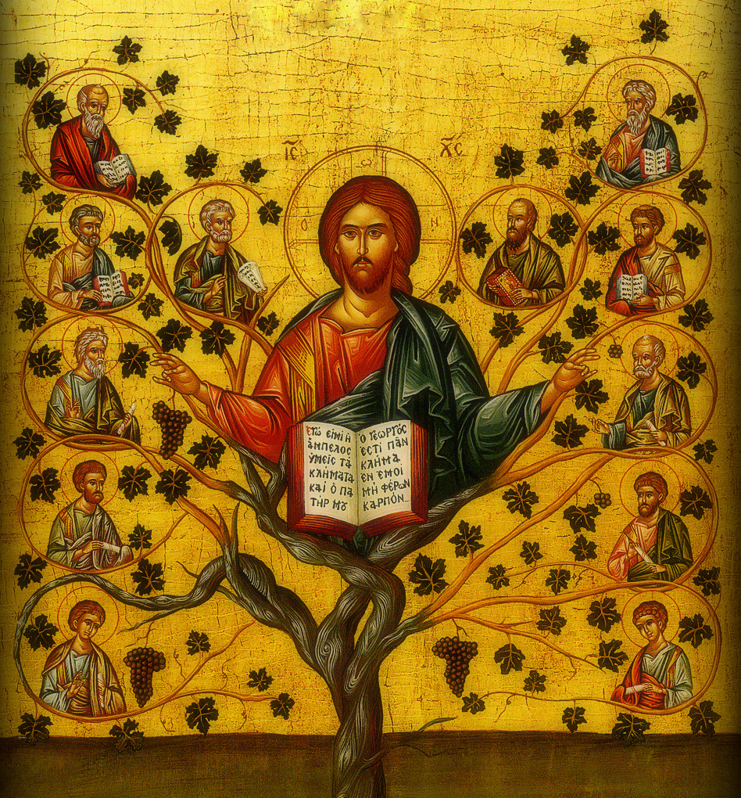


 1. form a parish stewardship team
- Form your stewardship team early
- Build a team of people blessed with a variety of gifts, training and experience
- Choose a Christ-centered chair with proven leadership and mentoring skills that lives as a true Orthodox Christian steward
 2. make a 12-month plan
- Create a 12-month parish stewardship calendar & put it in the church master calendar
- Plan for ongoing communication and personal contact with parishioners
- Schedule and assign tasks, communications, visitations and events
- Recognize that Stewardship is an ongoing ministry – not any single event or activity
 3. communicate
- Include a variety of messages pertaining to stewardship in bulletins, e-bulletins, newsletters, bulletin boards, etc.
- Plan a strategy of visitations or small group meetings
- Keep the parish council informed and active in promoting stewardship. Parish council members should lead by example
- Contact the Archdiocese for Stewardship resources
- Enlist parishioners to offer testimonials
- Offer sermons that apply the them of the Gospel lessons to aspects of Stewardship
 4. engage the people
- Get people personally involved in parish ministry
- Welcome new ideas and delegate responsibility
- Listen to and validate the concerns of parishioners
- Create opportunities for people to be heard
 5. utilize the 2013 theme
- Theme “…go and bear fruit…” (John 15:16)
- Icon: Christ the True Vine with permission from Aperges & Co.
- Application to Stewardship: We are called to bear fruit as branches of the True Vine which is Jesus Christ

