Come and See
Ερχου και Ιδε
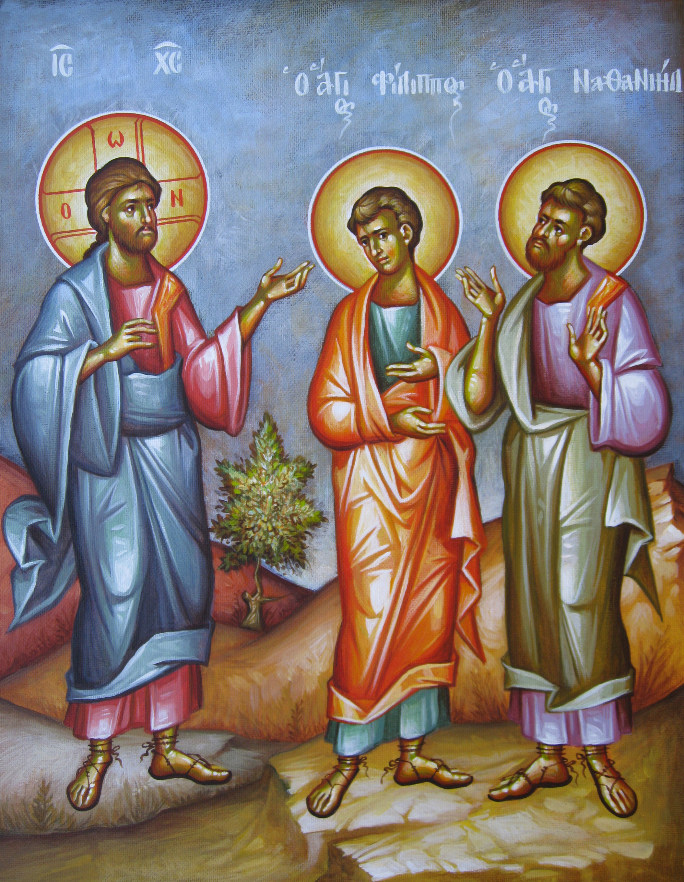

In the Gospel of John we read of the calling of the disciples…Philip finds Nathaniel, and said to him, “We have found him, of whom Moses in the law, and the prophets, did write, Jesus of Nazareth, the son of Joseph.” And Nathaniel said to him, “Can there any good thing come out of Nazareth?” Philip said to him, “Come and see” (John 1:45-46).

Each of us is also called to Come and See the One who brings us peace and understanding. The One who came to be our great example in life.

See the World as God’s Gift to You
Come and see God’s many blessings in your life. What is your response to His gifts? In gratitude and thanksgiving, you offer your time, talents and treasure in proportion to what you have been given.

Gregory the Theologian writes, “You will never overcome God’s generosity, even if you give away all that you have…. And however much you bring to him, always more remains. Nor will you give anything that is your own; for all things flow from God (Or 14.22).”

See What the Church can Become
Come and see what the Church can become – not just maintaining current programs, but doing the ministries made possible by your support.

In the early Church, every person coming to the gathering of the Church brought everything they could spare for the needs of the Church. They provided for the sustenance of the clergy, widows and orphans, for helping the poor, and for all the good works of the Church. This is the Church that we as Orthodox Christians claim to be.

How much can your offering do for Christ? -Only as much as you empower it to do. It depends on your love, because we give to Christ and His Church not according to our means but according to our love for Him. We are called to love God with our entire being – our time, talents and treasury.

See God Work through You

Come and see God work through you to serve His Church and those who seek His Truth.
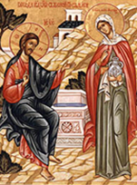
Remember the Samaritan woman at the well. After meeting Jesus “…The woman then left her water pot, and went her way into the city, and said to the men, Come, see a man, which told me all things that ever I did: is not this the Christ? Then they went out of the city, and came to him” (John 4).

God will place you in situations to share your faith. As He called upon His disciples on the day of His Ascension, He has also called upon you to be His witness“…in Jerusalem, and in all Judea and Samaria, and to the end of the earth.”

In the Gospel, we read of people coming to see Jesus. There were four individuals who also brought their friend, a paralyzed man, to be healed. When they found the place so crowded that they couldn’t get close, these friends removed part of the roof, and lowered their friend down on a stretcher and laid him at Jesus’ feet.

We also begin by bringing ourselves to Christ. But it doesn’t stop there. After we have brought ourselves, we bring others. The greatest gift we can give to another person is Christ and the ministries of the Church provide the opportunity to do so. But these ministries require our support.

We are able to fulfill God’s mission for the Church only to the extent that we support it. We do this by our physical, spiritual and financial support. Did you know that there are some 500 references in the Bible about prayer? But there are some 2300 references in the Bible about offering financial assistance to the Church to assist in transforming people.

Come and See
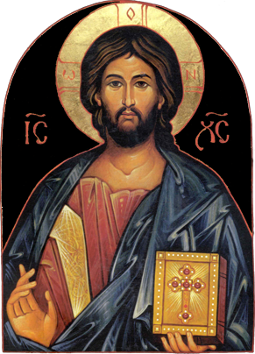
This Phrase is simple yet powerful. It calls us to change our location – physically and spiritually. If we want to find Christ, we must move toward Him. We must grow and mature in our faith.

Giving to the Church is an opportunity – an opportunity to examine our priorities and values. It is an opportunity to express our thankfulness, to give of ourselves and to grow in grace. It is an opportunity to participate in the work of God. Come and see what we can do together with your support.

A check mailed to the church is meaningless unless it is accompanied by our presence, by our willingness to serve, by our prayers, and by our commitment. Giving is not a substitute for our commitment – it is an expression of our commitment. Come and see how you can grow through service to the Church.

Come and see the works of God, Who is awesome (Psalm 66:5).

Consider…
Weekly Giving
In I Corinthinans 16:2 we read “On the first day of every week, each one of you should set aside a sum of money in keeping with his/her income.” Regular stewardship contributions are easier to manage and keep the Church and her ministries in our thoughts and plans. One way to do this is through automatically scheduled payments sent directly from your bank. In this way, we offer back to God the “first fruits” of our labor, realizing that all we possess comes from Him.

Cheerful Giving
In II Corinthians 9:7 we read “Each person should give what he/she has decided in his/her heart, not reluctantly or under compulsion, for God loves a cheerful giver.” Consider your weekly expenditures on entertainment, coffee, etc. Keep in mind that the expenses of the Church increase every year. In order to grow our ministries and meet our expenses, stewardship contributions must also increase each year.

Proportionate Giving
The more we are given, the more is expected of us. Each steward should determine the percentage of their income that will be committed to Christ and His Church.

Stewardship Ministries
Department of Stewardship, Outreach & Evangelism
Greek Orthodox Archdiocese of America
83 St Basil Road  Garrison, NY 10524
646/519-6160  Stewardship@goarch.org

Icon by the hand of Athanasios Clark

