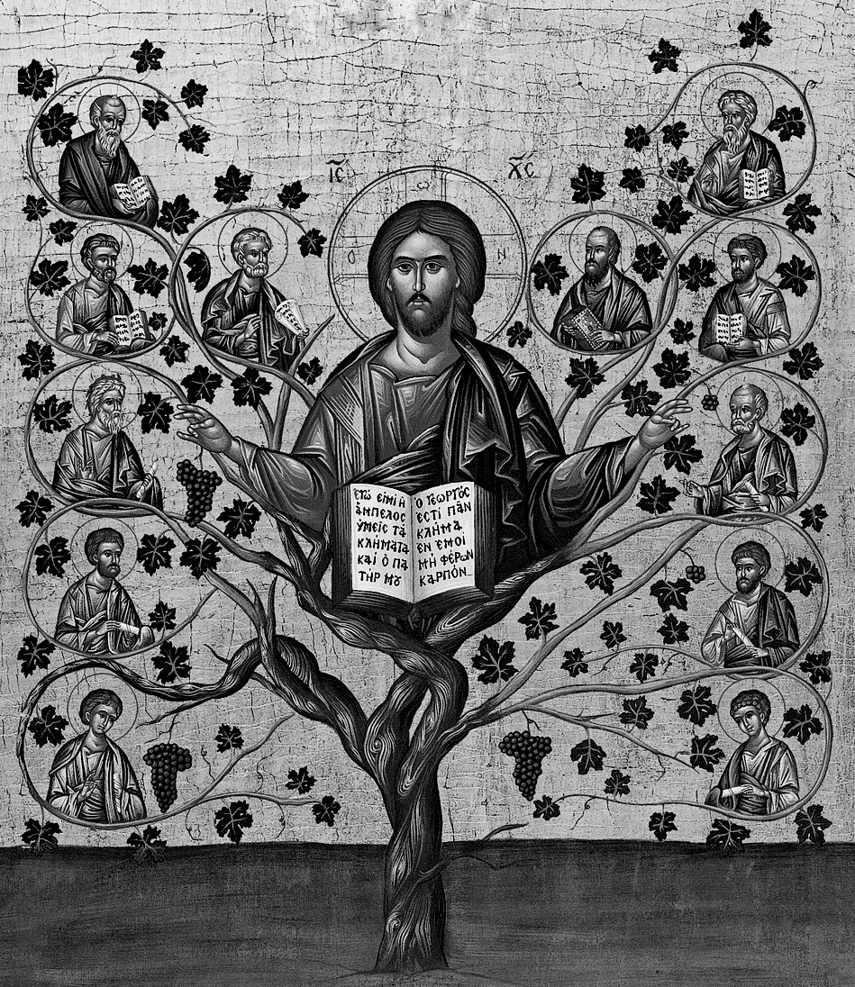

How Do We Bear Fruit?

We bear fruit for Jesus Christ when follow His example and love, serve and support the Church which is His Body. When we abide in Christ, we express this through generosity and devotion, especially in our financial stewardship and acts of personal generosity. Bearing fruit in the world is the visible result of our abiding in Christ.

By this My Father is glorified,
That you bear much fruit.”
John 15:8

Are You Bearing Fruit?
We all know the story of Jesus feeding the five thousand in the wilderness --- there was no food, except for one boy who had five loaves and two fish – not much when you consider 5000 men. But Jesus blessed the loaves, multiplied them and used them to feed the 5000.

That boy did his best with what he had. And Jesus used it to perform a beautiful miracle.

Just like the boy who offered his five loaves and two fish, we offer what we have – however great or small our gift. If we do this prayerfully and in humility, God will take our gifts and multiply them in order to feed His people.

