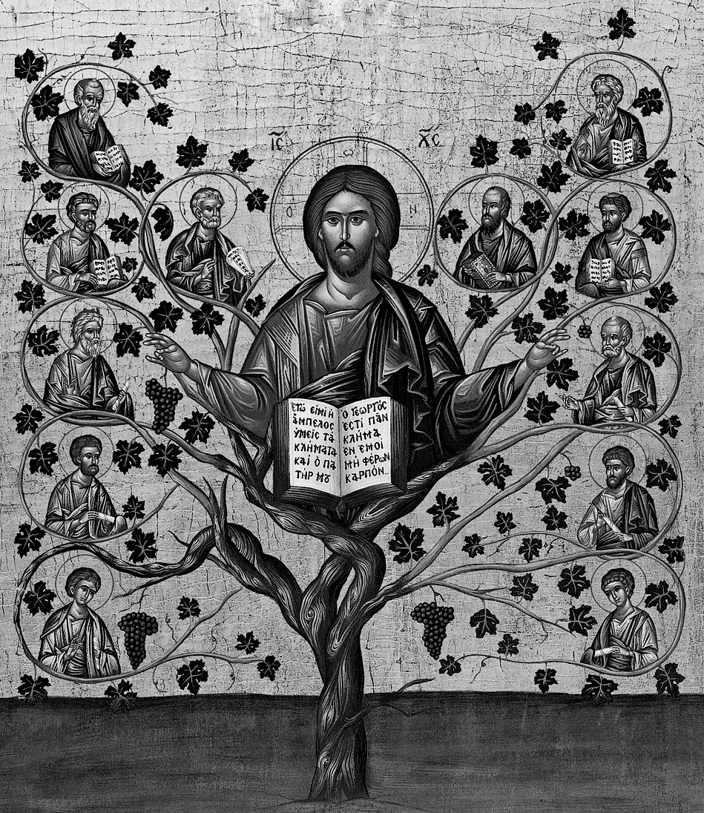

We are Called to Bear Fruit
At the Last Supper, as we read in Chapter 15 of the Gospel of John, Jesus instructed His disciples, “I Am the Vine; you are the branches.” He was telling us that the purpose of our abiding in Him is that we may bear fruit for God in the world. “By this My Father is glorified, that you bear much fruit…” (John 15:8). Just as the vine bears fruit only through its branches, so Jesus has chosen to work in the world through us. We are the members of His body – the branches through which the Vine must bear fruit. We bear fruit when we serve and support God and His Church.

What is Christian Stewardship?

Christian Stewardship is…

…learning how to be a responsible and concerned caretaker of Christ’s Church; it is learning how to enjoy Church life and be happy in Church work., for in Her dwells the fullness of the Spirit of God.

…our active commitment to use all our time, talent and treasure for the benefit of humankind in grateful acknowledgment of Christ’s redeeming love.

…caring for the needs of others.

…offering one’s self to God as He offered Himself to us.

…what a person does after saying “I believe…”, as proof of that belief.

…devotion and service to God and His Church as persons, as families, as diocese/metropolis, as national Church and as Church universal.

Williams & McKibben in Oriented Leadership

