Outreach & Evangelism Ministry | Greek Orthodox Archdiocese of America

Holy Communion

The Gift of Eternal Life

Father Alkiviadis Calivas

The Eucharist cannot be abandoned
Literary documents on the lives of saints often contain important information on Christian life, liturgy, and doctrine. One such document, which dates AD 304 at the height of the fierce persecutions initiated by the Emperors Diocletian and Maximian, is an eyewitness account that describes the trial of a group of Christians in a town in North Africa. Of particular interest is the testimony of two of those martyrs, Saturninus and his son Felix, about the Eucharist. Their words provide us with a concise statement that sums up the Church’s understanding of the Eucharist as it relates to communal and personal life. The group of martyrs was brought before the Roman proconsul. He addressed the following question to Saturninus, who was the leader of the group of Christians and a priest.

“Did you, contrary to the orders of the emperors, arrange for these persons to hold an assembly?”

Saturninus replied, “Certainly. We celebrated the Eucharist.”

“Why?” Asked the proconsul.

“Because the Eucharist cannot be abandoned.”

As soon as he said this, the proconsul ordered him to be put immediately on the rack to be tortured…

Then Felix, a son of Saturninus and a reader in the Church, came forward to the contest. Whereupon the proconsul inquired of him, “I am not asking you if you are a Christian. You can hold your peace about that! But were you one of the assembly; and do you possess any copies of the Scriptures?”

“As if a Christian could exist without the Eucharist, or the Eucharist be celebrated without a Christian!” answered Felix. “Don’t you know that a Christian is constituted by the Eucharist and the Eucharist by a Christian? Neither avails without the other. We celebrated our assembly right gloriously. We always convene at the Eucharist for the reading of the Lord’s Scriptures.”

Enraged by the confession, Anulinus the proconsul ordered Felix to be beaten with clubs.
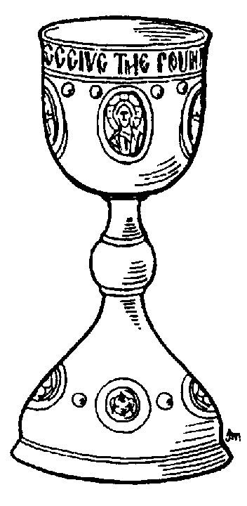
The key points of the testimony of the two ancient martyrs bear repeating because they highlight the meaning and the relation of the Eucharist to the faith community and to each of its members. “The Eucharist cannot be abandoned,” said the martyrs, because “a Christian cannot exist without the Eucharist, or the Eucharist be celebrated without a Christian.” “A Christian,” they affirmed, “is constituted by the Eucharist and the Eucharist by the Christian.”

In the paragraphs that follow I shall attempt to explain the meaning of these words by drawing your attention to several aspects of the Church’s teaching on the Eucharist, which is celebrated through the sacred rite of the Divine Liturgy and which many of us call Holy Communion. First, let me explain why the Eucharist cannot be abandoned; why it is the central activity of the Church.

The Eucharist: the central activity of the Church
The weekly celebration of the Eucharist on the Lord’s Day is an indispensable activity of the Church because the Eucharist constitutes the Church as the Body of Christ. It is the source and summit of her life, the supreme act of her thanksgiving and of her sacrifice of praise.

At the Divine Liturgy, the Church is continuously changed from a human community into the Body of Christ, the temple of the Holy Spirit, and the holy People of God. The life of every parish and of every faithful Christian is centered on the weekly celebration of the Divine Liturgy, for it is there that we experience the mystery of the new reality that is in the world; the reality that God wrought through the incarnation of His Son, our Lord Jesus Christ. In the Eucharist we encounter Christ – crucified, raised from the dead, and glorified – in His personal presence. Through the Divine Liturgy Jesus acts to fulfill his promises to His people: “Where two or three are gathered in my Name, there I am in the midst of the… And lo, I am with you always, to the close of the age” (Matt. 18: 20 and 28: 20).

The Divine Liturgy is more than texts, words, songs, and ritual acts. It is the meeting ground of heaven and earth. It is the place where people meet the self-giving of God and where, through this encounter, they meet their own human lives in unexpected form. The Divine Liturgy communicates to people the meaning and purpose of life – through Word and Sacrament. It helps us to see, understand, interpret, and internalize both the tragedy of human sin that blights our relationships but also the limitless expanse and potential of the new life in Christ.
We gather at the Divine Liturgy to affirm our identity as members of the Body of Christ, the Church. We gather to hear the Word of God; to confess our common faith; to express our indissoluble unity in love; and to find another life, new, true, and eternal. We receive Holy Communion “for the forgiveness of sins and life eternal.” The seeds of immortality and holiness are sown into our hearts and, thus empowered, we are sent forth to bear fruit commensurate to the wondrous Gift.
For these many reasons, the Eucharist cannot be abandoned and every activity of the parish – educational, social, philanthropic, or cultural – must always be informed by and serve the purposes of the Eucharistic assembly for which the parish essentially exists.

Through the Eucharist we become partakers of the divine nature
As we all know, the Eucharist was instituted by our Lord Jesus Christ at the Last Supper to perpetuate the remembrance of His redemptive, saving work and to establish a continuous intimate communion between Himself and those who believe in Him. Consequently, our weekly participation in the Divine Liturgy is not meant to fulfill a vague religious obligation, but to give evidence to our faith and to confirm the voluntary emptying of our sin-scarred self, so that we may become “partakers of the divine nature” (2 Peter 1: 4).

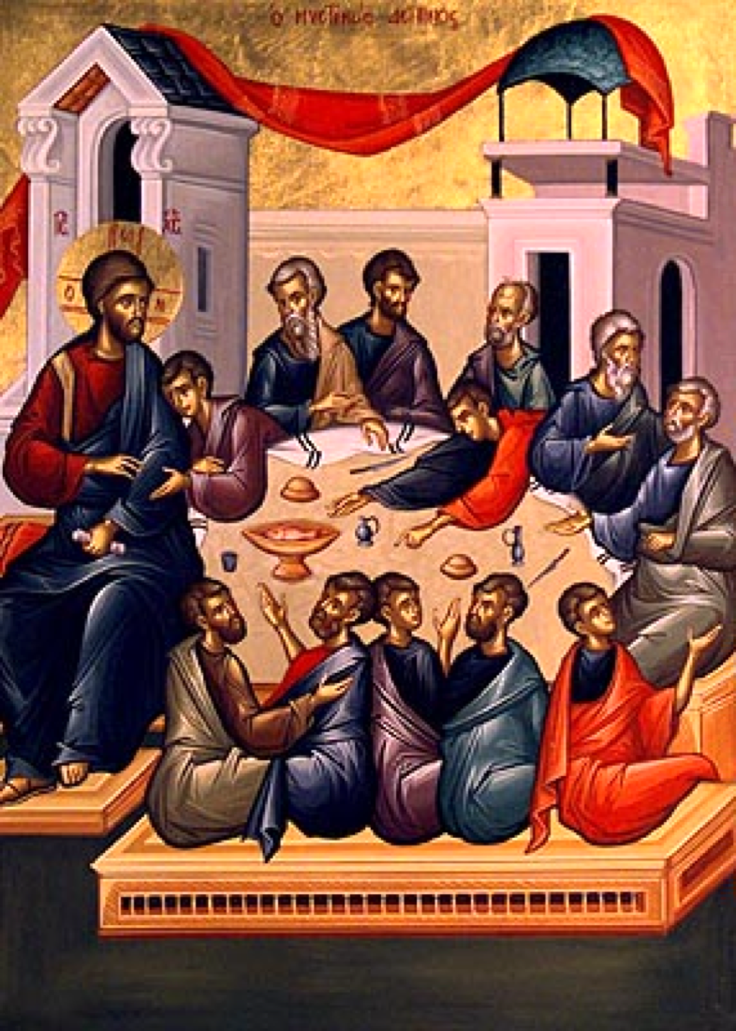
At the Divine Liturgy we are reminded that the Christian life is a work in progress. It is a life that is set on things above; that it is continuously moving from weakness to strength and from glory to glory. We learn that salvation is neither the product of biological and historical evolution, nor the result of some ethical code of behavior. Rather, salvation comes through a radical ontological change, which the Scriptures describe as ‘the putting off of the old man and the putting on of the new.’ We were immersed into this radical change when we were baptized, when our nakedness was clothed with Christ to become a new creation. The newness of life – the gift of Baptism – is constantly renewed, nourished, and advanced by the Eucharist when partaken in faith.

In the Eucharist, we pass continuously from death to life and obtain God Himself. By partaking of Holy Communion divine life flows into us and penetrates the fabric of our humanity. The future life is infused and blended into the present one. The Eucharist, as St. Ignatios of Antioch said, is “the medicine of immortality and the antidote against death, enabling us to live forever in Jesus Christ.” In Christ we become gods by grace.

We receive Holy Communion – the Body and Blood of Christ – with utter discernment, with humility and joy not as a reward for pious feelings and actions but as the most precious gift of the Lord to the members who comprise His Body, that we may enter into union with Christ, to become by grace flesh of Christ’s flesh so that we may share in what is divine, namely, immortality and incorruptibility. When we eat and drink worthily at the Eucharist, we are no longer clay, a heap of dust, but of the Body of Christ. For this reason the Eucharist cannot be abandoned because it constitutes both the Church and the Christian. The Eucharist, as the Church teaches us, is the food of life.

Holy Communion: the food of life
We have learned to equate food with life because food sustains our earthly existence. Our bodies are not self-sufficient. They do not possess life. We must constantly feed and maintain them with nourishment that comes from without. In the womb we are fed by our mother’s blood. After birth, we are fed by her milk and later by the food and drink that the earth provides. We have come to equate food with life.

Of all the creatures that inhabit the earth, we alone prepare food for eating, like the baking of bread and the making of wine. In fact, some form of bread and some type of wine constitute the sustaining elements of life in every human society. Consequently, bread and wine, the distinctive human food, have come to symbolize our mortal life.

We eat to live and speak of life in terms of food. But we also speak of life in terms of ‘flesh and blood.’ In fact, we cannot conceive of or know life except in terms of flesh and blood. A mother, for example, refers to her children – the fruit of her womb – as her flesh and blood. It is not hard therefore for us to recognize almost immediately the significant correlation between bread and wine and flesh and blood, the language that permeates the Eucharist. When we think of bread and wine or of flesh and blood we think of life. It is no accident, then, that bread and wine mixed with water are central to the Eucharistic mystery. Nor is it accidental that Jesus, when referring to His life, He spoke of it as flesh and blood and identified His life at the Last Supper with the distinctive human food, bread and wine.

At the Divine Liturgy, the Holy Spirit comes upon the holy Gifts – the bread and wine of the Eucharist – to change them into the Body and Blood of Christ. God accepts the bread and wine of our offering. In return He gives us His own Son, who acts to make us His own Body. Jesus nourishes all who are in a state of readiness and watchfulness with His own glorified flesh and makes them partakers of divine life. Christ, the Bread of Life, changes and transforms us who feed on Him in faith and assimilates us unto Himself, as He promised, “He who eats my flesh and drinks my blood abides in me and I in him (John 6: 56).

That is why the Eucharist cannot be abandoned. A Christian cannot live without it. It conforms our manner of being and thinking. When Christ is in us, the law of love – the self-giving, unconditional, sacrificial agape of God – becomes the inner principle, source, and guide of our life.

Holy Communion: the manifestation of selfless love
At the Divine Liturgy, Christ, the divine Bridegroom of the Church calls His people to sit together with Him at Table. At the Table of the Lord we are initiated time and again into the depths of the corporate life of the Church as communion in God and with God. The Eucharist unites us both to Christ and to one another, as the prayer of the Liturgy indicates. “And unite us all to one another who become partakers of the one Bread and the Cup in the communion of the Holy Spirit.”

Through the Eucharist, the divisive and destructive powers of Satan are being continuously defeated and the life of selfless love is revealed to God’s people so that they may learn it and be inspired to abide in it.

Empowered and perfected by Christ’s grace and mercy, the community and each of its members are called to become an epiphany of divine love, an image of the new humanity gathered around the risen and glorified Lord and living under His rule. No longer alienated from our true nature, we enter as free persons into a communion – koinonia – of love where everything that divides people is abolished. We exist not as we are, but as that which we will become.

Let us depart in peace
On this side of death every ascent requires a descent. So it is with our experiences at every celebration of the Divine Liturgy. We climb the rungs of the ladder of the divine ascent to be embraced by the boundless love of the Triune God – Father, Son, and Holy Spirit. We sit at Table with Him to hear the words of life and to partake of the Bread of life. But then, we are sent back, to ‘depart on peace.’ We are required to return to the world and to immerse ourselves in the affairs and circumstances of every day life, bringing the redemptive power of God and the blessings of the Eucharist to our wounded and broken world. Having partaken of the Body of Christ, we must now tend to the needs of broken human bodies and spirits that are all around us so that the rays of God’s Kingdom may shine in the darkness of our fallen world bringing healing, hope, peace, justice, and joy to the hearts of people, until the Lord comes in glory.

Father Alkiviadis Calivas,
Professor Emeritus of Liturgics
Holy Cross Greek Orthodox School of Theology

Father Alkiviadis Calivas is Professor Emeritus of Liturgics of Holy Cross Greek Orthodox School of Theology in Brookline, MA. Ordained in 1956 upon his graduation from Holy Cross, Fr. Calivas served as pastor of two large New York City parishes.

A Holy Cross School of Theology faculty member since 1978, Fr. Calivas has served the School in various capacities, including Director of Student Life, Chaplain, Dean of the School of Theology, Dean of the College, Administrative Director and President. He has served on several Councils, Boards and Commissions of the Archdiocese and was elected President of the Presbyters Council of the Archdiocese when it was established in 1970.

Fr. Calivas received his Doctor of Theology from the University of Thessaloniki in 1982. His publications include Come Before God in Prayer and Solemn Feast, Great Week and Pascha in the Greek Orthodox Church and a series of four volumes under the general title Essays in Theology and Liturgy.

